SAFETY DATA SHEET
OSHA HCS (29 CFR 1910.1200)

SECTION 1: PRODUCT AND COMPANY IDENTIFICATION
Product identifier
 | Chemical Family / Chemical Name | Mixture
 | CAS No. | Mixture
 | Trade Name | MC-1150
 | Product Code | None
Relevant identified uses of the substance or mixture and uses advised against
 | Identified Use(s) | Precipitant
 | Uses Advised Against | None
 | Company Identification | Meitler Consulting, Inc.  16979 Chieftain Road  Tonganoxie, KS 66086 USA
 | Telephone | (913) 422-9339
 | Fax | (913) 845-2950
 | E-mail | Info$
Emergency telephone number
 | Emergency Phone No. | Transportation Emergency: CHEMTREC 24 hr. 1-800-424-9300 / 1 (703) 527-3887 (Collect calls accepted)

SECTION 2: HAZARDS IDENTIFICATION
Classification of the substance or mixture
 | OSHA HCS (29 CFR 1910.1200) | Skin Corr. 1B; Eye Dam. 1; Met. Corr. 1
Label elements
 | Hazard Symbol | 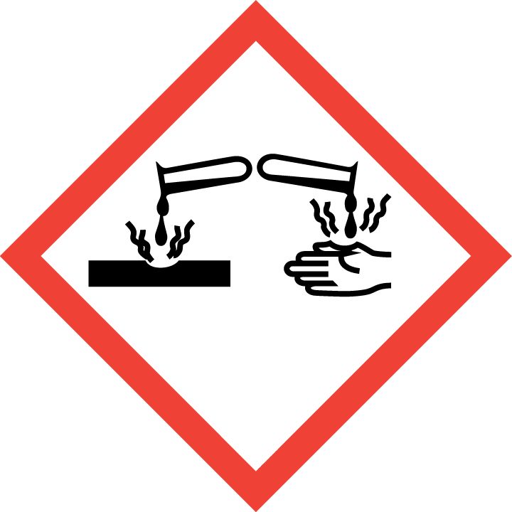
 | Signal Word(s) | DANGER
 | Hazard Statement(s) | Causes severe skin burns and eye damage.  May be corrosive to metals.
 | Precautionary Statement(s) | Wear protective gloves/protective clothing/eye protection/face protection.  Wash thoroughly after handling.  IF ON SKIN: Wash with plenty of soap and water. If irritation (redness, rash, blistering) develops, get medical attention.  IF IN EYES: Rinse cautiously with water for several minutes. Remove contact lenses, if present and easy to do. Continue rinsing. Get immediate medical attention.  IF SWALLOWED: rinse mouth. Do NOT induce vomiting. Seek medical treatment.
Other hazards |  | Contact with acids liberates very toxic gas. Toxic to aquatic life.
Additional Information |  | Warning - this preparation contains a substance not yet tested completely. (>10%)

SECTION 3: COMPOSITION/INFORMATION ON INGREDIENTS

Hazardous Ingredient(s) | % wt. | CAS No.
Proprietary hydropolysulfide, carbonothioylbis-, disodium salt solution | Trade Secret | Trade Secret
Sodium hydrosulfide | 20 - 25 | 16721-80-5
Other proprietary ingredients / components | Trade Secret | Trade Secret
Additional Information - Substances in the product which may present a health or environmental hazard, or which have been assigned occupational exposure limits, are detailed below.:
- Contact with acids liberates very toxic gas.: Hydrogen sulfide (H₂S)

SECTION 4: FIRST AID MEASURES


Description of first aid measures
 | Inhalation |  | Remove to fresh air and keep at rest in a position comfortable for breathing. If breathing is laboured, administer oxygen. If symptoms occur obtain medical attention.
 | Skin Contact |  | Wash affected skin with plenty of water. If irritation (redness, rash, blistering) develops, get medical attention.
 | Eye Contact |  | Rinse cautiously with water for several minutes. Remove contact lenses, if present and easy to do. Continue rinsing. Get immediate medical attention.
 | Ingestion |  | DOCVARIABLE GMSDSGHS000000000103 \* MERGEFORMATIf ingested, rinse mouth. DOCVARIABLE GMSD00007AA0001 \* MERGEFORMATDo not induce vomiting. Seek medical treatment.
Most important symptoms and effects, both acute and delayed |  |  | None anticipated
Indication of any immediate medical attention and special treatment needed |  |  | Treat symptomatically

SECTION 5: FIRE-FIGHTING MEASURES
Extinguishing Media
-Suitable Extinguishing Media |  | Non-combustible / Non-flammable. As appropriate for surrounding fire.
-Unsuitable Extinguishing Media |  | As appropriate for surrounding fire.
Special hazards arising from the substance or mixture |  | None known.
Advice for fire-fighters |  | A self contained breathing apparatus and suitable protective clothing should be worn in fire conditions. Keep containers cool by spraying with water if exposed to fire.

SECTION 6: ACCIDENTAL RELEASE MEASURES
Personal precautions, protective equipment and emergency procedures | Put on protective equipment before entering danger area. Wear protective gloves/protective clothing/eye protection/face protection.
Environmental precautions | Prevent substance entering sewers.
Methods and material for containment and cleaning up | Cover spills with inert absorbent material. Transfer to a container for disposal or recovery.
Reference to other sections | None
Additional Information | None

SECTION 7: HANDLING AND STORAGE
Precautions for safe handling | Wear protective gloves/protective clothing/eye protection/face protection. When using do not eat, drink or smoke.
Conditions for safe storage, including any incompatibilities
-Storage temperature | No special measures are required.
-Incompatible materials | Contact with acids liberates very toxic gas.
Specific end use(s) | Precipitant

SECTION 8: EXPOSURE CONTROLS/PERSONAL PROTECTION
Occupational Exposure Limits
Contact with acids liberates very toxic gas.: Hydrogen sulfide (H₂S)

SUBSTANCE. | CAS No. | (8hr TWA) |  | STEL |  | Note:
SUBSTANCE. | CAS No. | PEL  (OSHA) | TLV  (ACGIH) | PEL  (OSHA) | TLV  (ACGIH) | Note:
Hydrogen sulfide (H₂S) | 7783-06-4 | ---- | 1 ppm | 20 ppm (Ceiling)* | 5 ppm | 50 ppm (Peak) - 10 min.^
^ once, only if no other meas. exp. occurs

Recommended monitoring method |  | Real-time (electrochemical sensors)
Exposure controls
Appropriate engineering controls |  |  |  | Ensure that the eye flushing systems and safety showers are located close to the working place.
Personal protection equipment
 | Eye/face protection   |  |  | The following to be used as necessary: Goggles giving complete protection to eyes. Full face shield.
 | Skin protection (Hand protection/ Other)   |  |  | The following to be used as necessary:Gloves (Neoprene or Natural rubber). Chemical protection suit. Wear safety or chemical resistant shoes or boots. Check with protective equipment manufacturer's data.
 | Respiratory protection   |  |  | Normally no personal respiratory protection is necessary.
 | Thermal hazards |  |  | Not normally required. Use gloves with insulation for thermal protection, when needed.
Environmental Exposure Controls |  |  |  | Collect all precipitate. Disposal should be in accordance with local, state or national legislation.

SECTION 9: PHYSICAL AND CHEMICAL PROPERTIES
Information on basic physical and chemical properties
Appearance | Liquid
Color. | Light Red
Odor | Sulfur-like
Odor Threshold (ppm) | Not available
pH (Value) | 12.0 - 12.5
Melting Point (°C) / Freezing Point (°C) | ca. 0 (32 °F)
Boiling point/boiling range (°C): | ca.100 (212 °F)
Flash Point (°C) | Non-combustible / Non-flammable
Evaporation Rate | Similar to Water
Flammability (solid, gas) | Not applicable
Explosive Limit Ranges | Not applicable
Vapour pressure (Pascal) | Similar to Water
Vapour Density (Air=1) | Similar to Water
Density (g/ml) | 1.125 - 1.150
Solubility (Water) | Miscible
Solubility (Other) | Not available
Partition Coefficient (n-Octanol/water) | Not available
Auto Ignition Point (°C) | Non-combustible / Non-flammable
Decomposition Temperature (°C) | Not available
Kinematic Viscosity | Similar to Water
Explosive properties | Not explosive.
Oxidizing properties | Not oxidizing.
Other information | Not available

SECTION 10: STABILITY AND REACTIVITY
Reactivity | Stable under normal conditions.
Chemical stability | Stable.
Possibility of hazardous reactions | Contact with acids liberates very toxic gas.
Conditions to avoid | Incompatible materials
Incompatible materials | Acids
Hazardous decomposition product(s) | Hydrogen sulfide gas

SECTION 11: TOXICOLOGICAL INFORMATION
Exposure routes: Skin Contact, Eye Contact

Acute toxicity | Oral: LD50 - Not determined  Dermal: LD50 - Not determined
Irritation/Corrosivity | Causes severe skin burns and eye damage.
Sensitization | No information available
Repeated dose toxicity | No information available
Carcinogenicity | No data. It is unlikely to present a carcinogenic hazard to man.
NTP | IARC | ACGIH | OSHA | NIOSH
No. | No. | No. | No. | No.

Mutagenicity | No information available
Toxicity for reproduction | No information available

SECTION 12: ECOLOGICAL INFORMATION

Toxicity
Short term | LC50 (48 hour) = 56 mg/L (Ceriodaphnia dubia; water flea)  LC50 (48 hour) = 55.4 mg/L (Daphnia mangna; water flea)  LC50 (96 hour) = 15.8 mg/L (Pimephales promelas; fathead minnow)
Long Term | Not available
Persistence and degradability | Not available
Bioaccumulative potential | The product has low potential for bioaccumulation.
Mobility in soil | Not available
Results of PBT and vPvB assessment | Not classified as PBT or vPvB.
Other adverse effects | None known.

SECTION 13: DISPOSAL CONSIDERATIONS
Waste treatment methods | Disposal should be in accordance with local, state or national legislation.Consult an accredited waste disposal contractor or the local authority for advice.

SECTION 14: TRANSPORT INFORMATION
 | Land transport  (U.S. DOT) | Sea transport  (IMDG) | Air transport (ICAO/IATA)
UN number | UN 3266 | UN 3266 | UN 3266
Proper Shipping Name | Corrosive liquid, basic, inorganic, n.o.s. (Carbonothioylbishydropolysulfide disodium salt and sodium hydrosulfide)
Transport hazard class(es) | 8 | 8 | 8
Packing group | II | II | II
Hazard label(s) | Corrosive | Corrosive | Corrosive
Environmental hazards | Yes * | No | No
Special precautions for user | None assigned | None assigned | None assigned
Transport in bulk according to Annex II of MARPOL73/78 and the IBC Code: Not established.
*Contains Sodium Hydrosulfide which has a Reportable Quantity (RQ) of 5,000 lbs. The proper shipping name for containers exceeding 2,000 gallons must include the “RQ” designation.

SECTION 15: REGULATORY INFORMATION
Safety, health and environmental regulations/legislation specific for the substance or mixture:
TSCA (Toxic Substance Control Act) - Inventory Status: All components listed or polymer exempt.
Designated Hazardous Substances and Reportable Quantities (40 CFR 302.4):
 | Chemical Name | CAS No. |  |  | Typical %wt. |  |  |  | RQ (Pounds)
 | Sodium hydrdosulfide | 16721-80-5 |  |  | 20 - 25 |  |  |  | 5000
SARA 311/312 - Hazard Categories: Refer to SECTION 2 - HAZARDS IDENTIFICATION
SARA 313 - Toxic Chemicals (40 CFR 372):
 | Chemical Name |  |  |  |  | CAS No. |  |  |  |  | Typical %wt.
 | None |  |  |  |  | ---- |  |  |  |  | ----
SARA 302 - Extremely Hazardous Substances(40 CFR 355):
 | Chemical Name |  |  | CAS No. |  |  |  | Typical %wt. |  | TPQ (pounds)
 | None |  |  | ---- |  |  |  | ---- |  | ----
California Proposition 65 List:
 | Chemical Name |  | CAS No. |  |  |  | Type of Toxicity
 | None |  | ---- |  |  |  | ----

SECTION 16: OTHER INFORMATION
The following sections contain revisions or new statements:
Date of preparation: January 4, 2021
Additional Information: None

Disclaimer: We believe the statements, technical information and recommendations contained herein are reliable, but they are given without warranty or guarantee of any kind. The information contained in this document applies to this specific material as supplied. It may not be valid for this material if it is used in combination with any other materials. It is the user’s responsibility to satisfy oneself as to the suitability and completeness of this information for the user’s own particular use.

