Safety Data Sheet
Rev. Date: 01/25/2021
1. PRODUCT AND COMPANY IDENTIFICATION
Product Name: Dry Citric Acid Anhydrous

Synonyms/Generic Names: 2-hydroxy- 1,2,3-propanetricarboxylic acid, or 2-hydroxypropane-1,2,3-tricarboxylic acid

Product Use: Chemical intermediate, Personal care products, cleaning/detergent products and other household products, paper products, construction products, polymers and plastics products, oil industry, textile industry, paints and coatings, photography products, laboratory reagents, water treatment, treatment of metal surfaces, agricultural applications, medical devices, food additive.

Manufacturer: Meitler Consulting, Inc.
16979 Chieftain Road
Tonganoxie, KS 66086

For More Information Call: 913-422-9339 (Monday-Friday 8:00am-5:00pm)
For Emergency Call: CHEMTREC- 800-424-9300 (CCN 1635)

2. HAZARDS IDENTIFICATION
Emergency Overview
Warning. Irritating to eyes. Corrosive to metals (as aqueous solution). Product dust may cause mild, mechanical irritation. May form combustible dust concentrations in air (during processing and handling).
Appearance Physical State Odor
White Solid: Powder/Granular Odorless

This product IS classified as hazardous according to 29 CFR 1910.1200 (known as HCS 2012), amended to conform to the United Nations’ Globally Harmonized System of Classification and Labeling of Chemicals (GHS). Depending on the intended use, this product is classified as hazardous according to the criteria contained in the Hazardous Products Regulations (SOR/2015-17), also known as WHMIS 2015.
NOTE: Certain products covered under other Canadian legislation, including but not limited to cosmetics, devices, drugs or food (as defined in the Food and Drugs Act), pest control products (as defined in the Pest Control Products Act), consumer products )as defined in the Canada Consumer Product Safety Act), and Hazardous waste (being a hazardous product that is sold for recycling or recovery and is intended for disposal), are NOT subject to the label and SDS requirements of the Hazardous Products Regulations (SOR/2015-17), also known as WHMIS 2015. As supplied for use in food, an SDS and WHMIS compliant labeling are NOT required for this product. Since Canadian employers must still provide education and training on health effects, safe use, and storage, and in the interest of providing relevant product information to our customers, this SDS is being provided on a voluntary basis.
Serious Eye Damage/Eye Irritation | Category 2
OSHA Defined Hazard(s) | Combustible Dust
HPR Defined Hazard(s) | Combustible Dust

Label Elements
NOTE: While label elements are provided within this SDS, under 29 CFR 1910. 1200 (b)(5), products already subject to the labeling requirements of other specified federal acts, may be exempt from OSHA labeling.
Signal Word | Warning
GHS Hazard Pictogram(s):
Hazard Statement(s): | H319 Causes serious eye irritation. May form combustible dust concentrations in air.
Prevention Precautionary Statement(s): | Wash hands and exposed skin throoughly after handling. Wear eye/face protection.
Response Precautionary Statement(s): | If in eyes: Rinse cautiosly with water for several minutes. Remove contact lenses, if present and easy to do. Continue rinsing. If eye irritation persists: Get medical advice.

3. COMPOSITION/INFORMATION ON INGREDIENTS
Chemical nature of the preparation: Substance
Chemical Family: Acids
Molecular Formula: C₆H₈O₇

The following component(s) in this product are considered hazardous under applicable OSHA (USA), WHMIS (Canada), and/or NOM-002-SCT-2003 (Mexico) regulations (or require disclosure as an air contaminant)
Chemical Name | CAS-No | Weight % | North America Substance Hazard Class
Citric acid | 77-92-9 | 99-100 | Eye Irritation 2;

4. FIRST AID MEASURES
Description of first aid measures
Eye Contact: Immediately flush with plenty of water. After initial flushing, remove any contact lenses and continue flushing for at least 15 minutes. If symptoms persist, call a physician.
Skin Contact: Wash off immediately with soap and plenty of water removing all contaminated clothes and shoes.
Inhalation: Move to fresh air.
Ingestion: Clean mouth with water and afterwards drink plenty of water.
Protection of First aiders: Use personal protective equipment. Avoid contact with skin, eyes and clothing.
General Advice: If symptoms persist, call a physician. Show this safety data sheet to the doctor in attendance. Use personal protective equipment. For personal protection see section 8.
Most important symptoms and affects, both acute and delayed
Eyes: Irritating to eyes. Contact with eyes may cause mechanical irritation.
Skin: According to GHS hazard classification criteria, the product is not considered as being a skin irritant. Product dust may cause mild, mechanical irritation. Health injuries are not known or expected under normal use.
Inhalation: May cause irritation of respiratory tract. Based on the low pH, critic acid would be expected to cause irritation to the respiratory tract, resulting in a higher cough response as the inhalation exposure concentration was increased.
Ingestion: Oral exposure is not anticipated under normal working conditions. Health injuries are not known or expected under normal use.
Main Symptoms: Itching. Redness. Burning sensation.

Indication of any immediate medical attention and special treatment needed
Notes to Physician: Treat symptomatically.

5. FIRE-FIGHTING MEASURES
Flammable Properties
Fine dust dispersed in air may ignite. Risk of ignition followed by flame propagation or secondary explosions should be prevented by avoiding accumulation of dust, e.g. on floors and ledges.
Extinguishing media
Suitable Extinguishing Media: Dry chemical. Carbon dioxide (CO₂). Water spray. Foam. Use extinguishing measures that are appropriate to local circumstances and the surrounding environment.
Unsuitable Extinguishing Media: No information available.
Special hazards arising from the substance or mixture
Hazardous Combustion Products: Thermal decomposition can lead to release of irritating gases and vapors, Carbon monoxide (CO), Carbon dioxide (CO₂).
Specific Hazards Arising from the Chemical: None known.
Sensitivity to mechanical impact: No
Sensitivity to static discharge: Yes (as dust)
Further information: Fine dust dispersed in air may ignite. Dust explosibility class=1. Weak to moderately explosible.
Advice for fire-fighters
Protective Equipment and Precautions for Firefighters: As in any fire, wear self-contained breathing apparatus pressure-demand, MSHA/NIOSH (approved or equivalent) and full protective gear.
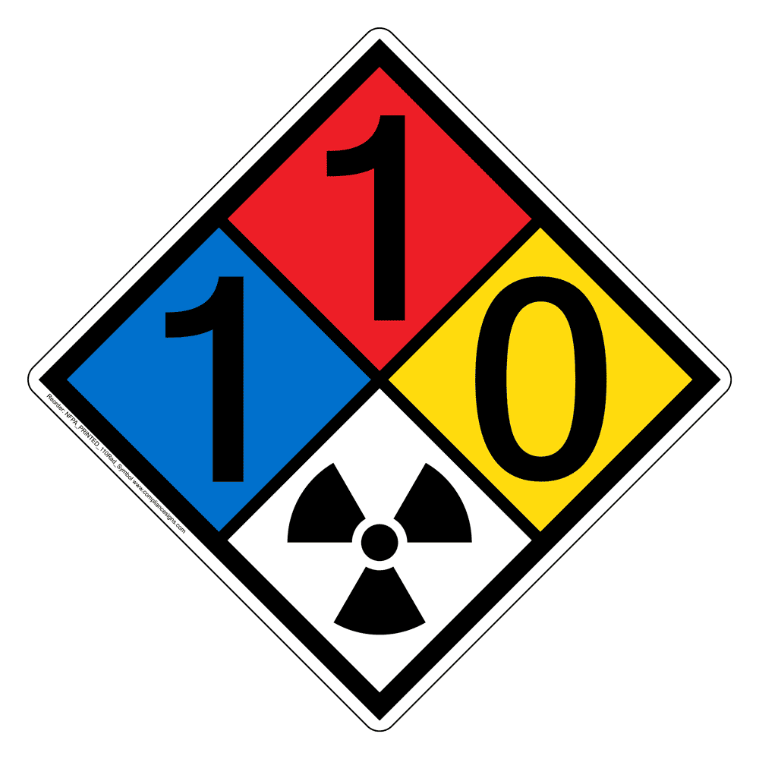
NFPA Health 1
Flammability 1
Stability and Reactivity 0
Physical Hazard None known

6. ACCIDENTAL RELEASE MEASURES
Personal Precautions, Protective Equipment, and Emergency Procedures
Avoid contact with the skin and the eyes. Use personal protective equipment. For personal protection see section 8. Avoid dust formation.

Environmental Precautions
Prevent further leakage or spillage if safe to do so. Prevent product from entering drains.
Methods and Materials for Containment and Cleaning Up
Pick up and transfer to properly labelled containers. Avoid dust formation. Keep in suitable, closed containers for disposal. Aqueous spillage should be neutralized and treated prior to discharge. For disposal information see section 13.

7. HANDLING AND STORAGE
Handling
Wear personal protective equipment. Avoid contact with skin, eyes and clothing. Handle in accordance with good industrial hygiene and safety practice. Do not breathe vapors/dust. Use only in area provided with appropriate exhaust ventilation. Avoid dust formation in confined areas. Fine dust dispersed in air may ignite. Ensure adequate ventilation. Refer to NFPA 61, “Standard for the Prevention of Fires and Dust Explosion in Agricultural and Food Processing Facilities”.

Storage
Keep containers tightly closed in a cool, well-ventilated place. Keep in properly labelled containers. Keep at temperature not exceeding 23.9 C / 75 F at 23.9 relative humidity. Keep away from metals. Corrosive to metals (as aqueous solution). Keep away from oxidizing agents. Keep away from strong bases. Keep away from amines.

8. EXPOSURE CONTROLS/PERSONAL PROTECTION
Exposure Limits
Where exposure limits have not been established for specific components of this material, please observe the OSHA and ACGIH established limits for particulates not otherwise classified (PNOC). OSHA PEL: [15mg/m³ (total dust) 8-hr TWA], [5mg/m³ (respirable) 8-hr TWA]. ACGIH TLV: [10mg/m³ (inhalable) 8-hr TWA], [3mg/m³ (respirable) 8-hr TWA].

Biological Limit Values
No biological limit values have been listed for the component(s) of this product.

Appropriate Engineering Controls Local exhaust ventilation. Ensure adequate ventilation, especially in confined areas.
General Hygiene Considerations When using, do not eat, drink, or smoke. Regular cleaning of equipment, work area and clothing.

Personal Protective Equipment
Eye/face Protection Safety glasses with side-shields. If airborne dust concentrations are excessive, wear goggles.
Skin and Body Protection Impervious gloves. Long sleeved clothing. Boots
Respiratory Protection Respirator with a dust filter. In case of insufficient ventilation wear suitable respiratory equipment.
9. PHYSICAL AND CHEMICAL PROPERTIES
Appearance White
Physical State Solid: Powder/Granular
Odor Odorless
Odor Threshold Not Applicable
pH 1 .8 @ 25 C at 5wt% conc
Dissociation Constants (pKa) 3.13, 4.76, and 6.4 at 25 C
Flash Point Not applicable (solid)
Autoignition Temperature Not applicable
Boiling point Not applicable
Melting/Freezing point 153 C / 307 F (101.3 kPa)
Decomposition temperature No Information available
Oxidizing Properties Not oxidizing
Flammability Limits in Air Not flammable
Explosive Limits Not explosive
Water Solubility(ies) 590g/l at 20 C
Surface Tension Not applicable
Evaporation Rate Not applicable
Vapor Pressure 2.21 E-6 Pa at 25 C Not applicable
Vapor Density Not applicable
Specific Gravity/Relative Density 1.665g/m³ at 20 C
Bulk Density 500-950kg/m³ at 20 C
Viscosity (kinematic) Not applicable (solid)
Partition Coefficient -0.2 to -1.8
(n-octanol/water)
Explosive Properties Not explosive

10. STABILITY AND REACTIVITY
Reactivity Reactions with metal nitrates may be potentially explosive. Aqueous form is corrosive to copper, zinc, aluminum, and their alloys.
Stability Not applicable. Stable under normal conditions
Possibility of Hazardous Reactions None under normal processing
Conditions to Avoid Avoid dust formation. Heat, flames, and sparks.
Incompatible Materials Amines. Heavy metals. Strong oxidizing agents. Strong bases.
Hazardous Decomposition Products Thermal decomposition can lead to release of irritating gases and vapors. Carbon monoxide (CO). Carbon dioxide (CO₂).

11. TOXICOLOGICAL INFORMATION
Information on toxicological effects

Acute toxicity | Based on available data, the classification criteria are not met.

Chemical Name | Weight % | LD50 Oral | LD50 Dermal | LC50 Inhalation
Citric Acid | 99-100 | 5400 mg/kg Mouse 11700 mg/kg Rat | >2000 mg/kg bw Rat

Skin corrosion/irritation | Based on available data, not, or only slightly irritation
Serious eye damage/eye irritation | Irritant, causes serious eye irritaton.
Method Species Results | OECD Guideline 405 (Acute Eye Irritation/Corrosion) Rabbit (New Zealand White) Irritation: Overall irritation score for 10% solution: 9.3 of max. 110 (mean (of 3 animals)) (Time point: at 1,24,48 or 72H) (fully reversible within: 7 days) (score achieved at 1h) Overall irritation score for 30 % solution: 16 of max. 110 (mean (of 3 animals)) (Time point: at 1, 24, 48 or 72h) (not fully reversible within:14 days) (fully reversible in 14-21 days) (expert opinion) (score achieved at 1h)
Respiratory or skin sensitization | Based on available data, not expected to be a skin or respiratory sensitizer
Germ cell mutagenicity | Based on available data, negative to test/non-mutagenic
Carcinogenicity | Based on available data, no evidence of carcinogenicity
Reproductive toxicity | Based on available data, no evidence of reproductive toxicity
STOT- single exposure | No evidence of toxicity
STOT- repeated exposure | Based on available data, no toxicity identified at highest exposure levels [NOAEL (rats) 4000mg/kg bw/d].
Aspiration hazard | Based on available data, no known aspiration hazard.

Potential health effects
Eyes Irritating to eyes. Contact with eyes may cause mechanical irritation.
Skin According to GHS hazard classification criteria, the product is not considered as being a skin irritant. Product dust may cause mild, mechanical irritation. Health injuries are not known or expected under normal use.
Inhalation May cause irritation of respiratory tract. Based on the low pH, citric acid would be expected to cause irritation to the respiratory tract, resulting in a higher cough response as the inhalation exposure concentration was increased.
Ingestion Oral exposure is not anticipated under normal working conditions. Health injuries are not known or expected under normal use.
Main Symptoms Itching. Redness. Burning sensation.

12. ECOLOGICAL INFORMATION

Ecotoxicity
Not classified for aquatic toxicity. Contains no substances known to be hazardous to the environment. Contains no substances known to be not degradable in waste water treatment plants.
Chemical Name | Fresh Water Algae | Acute Fish Toxicity | Daphnia (Water flea) | Effects on micro-organisms | Other
Citric acid | NOEC (8d): 425 mg/l (nominal) | LC50(48h):440mg/l (Leuciscusidus)nominal) | EC50(24h): 1535 mg/l (Daphniamagna)(nominal)
Determined by extrapolation (testing of intrinsic toxicity to algae impractical due to nutrient complexing behaviour of citric acid)

Predicted No Effect Concentrations (PNEC) – Determined by extrapolation
Chemical Name | Aqua (fresh water) | Aqua (marine) | Sewage Treatment Plant | Sediment (fresh water) | Sediment (marine) | Soil
Citric acid | 0.44mg/l | 0.044mg/l | >1000mg/l | 34.6mg/kg sediment dw | 3.46mg/kg sediment dw | 33.1mg/kg

BCF Bioaccumulation is unlikely. [Logkow < 0]
Chemical Name | Log Kow | BCF
Citric acid | -0.2 to -1.8 | BCF ~ 3.2 (estimated)

Persistence/Degradability Readily biodegradable
Mobility Soluble in water
PBT and vPvB assessment This substance is not considered to be persistent, bioaccumulating nor toxic (PBT).
Other adverse effects Nothing specific known.

13. DISPOSAL CONSIDERATIONS
Whenever possible, as rules and regulations allow, please recycle or manage materials to minimize waste.

Waste Disposal Methods Dispose of in compliance with the laws and regulations pertaining to this product in your jurisdiction. Rinsewater resulting from cleanup should be collected for treatment before disposal. Solutions with low pH-value should be neutralized before discharge.
Contaminated Packaging Empty containers should be decontaminated and taken for local recycling, recovery, or waste disposal.

14. TRANSPORT INFORMATION
Domestic transport regulations (USA)
DOT Not regulated

Domestic transport regulations (Canada)
TDG Not regulated

Domestic transport regulations (Mexico)
MEX Not regulated

International transport regulations
ICAO Not regulated
IATA Not regulated
IMDG/IMO Not regulated.
15. REGULATORY INFORMATION
International Inventories
The components of this product are reported in the following inventories:
Chemical Name | TSCA | DSL | NDSL | ICL | EINECS | ELINCS | AICS
Citric acid | Yes | Yes | No | No | Yes 201-069-1 | No | Yes

Chemical Name | ENCS ISHL | CHINA | PICCS | KECL | Taiwan | Turkey | NZIoC
Citric acid | Yes  (2)-1318 | Yes | Yes | Yes  KE-20831 | Yes | Yes  201-069-1 | No

USA
Federal Regulations
Ozone Depleting Substances:
No class l or Class ll material is known to be used in the manufacture of, or contained in, this product.

SARA 313
Section 313 of Title lll of the Superfund Amendments and Reauthorization Act of 1986 (SARA). This product is not known to contain any chemicals which are subject to the reporting requirements of the Act or regulations contained in 40 CFR 372.

CERCLA/SARA 103-302
Sections 103-302 of Title lll of the Superfund Amendments and Reauthorization Act of 1986 (SARA). This product is not known to contain any chemicals which are subject to the reporting requirements of the Act or regulations contained in 40 CFR 103-302.

SARA 311/312 Hazardous Categorization
Refer to the OSHA hazard classification(s) provided in section 2 of this SDS.
Acute Health Hazard Yes
Chronic Health Hazard No
Fire Hazard Yes (when in the form of combustible dust)
Sudden Release of Pressure Hazard No
Reactive Hazard No

Clean Air Act, Section 112 Hazardous Air Pollutants (HAPs) (see 40 CFR 63)
This product is not known to contain any HAPS.

State Regulations

State Right-to-Know
No known component subject to “Right-To-Know” legislation.

Canada
(NPRI) Canadian National Pollutant Release Inventory
No Known component is listed on NPRI.

Mexico
Mexico-Grade Moderate risk, Grade 2

16. OTHER INFORMATION
Prepared by: Meitler Consulting, Inc.
Revision Date: 01/25/2021
Revision Number: 1
Reason for revision: New SDS format. This version replaces all previous versions.

A1- Known Human Carcinogen
A2- Suspected Human Carcinogen
A3- Animal Carcinogen
A4- Not classifiable as a human carcinogenACGIH TLV- American Conference of Governmental Industrial Hygienists Threshold Limit Values
CAS- Chemical Abstract Service
Ceiling- Ceiling Limit Value: Concentrations that should never be exceeded at any given time (instantaneous)
CHINA- Chinese Inventory of Existing Chemical Substances (China)
CLP- Classification, Labeling and Packaging, Regulation (EC) 1272/2008
CSA- Chemical Safety Assessment
CSR- Chemical Safety Report
Delisted- Substances Delisted from Report on Carcinogens
DNEL- Derived No Effect Level
DOT- U.S. Department of Transportation
DSL- Domestic Substance List (Canada)
EC- European Commission
EC No. – European Community number
EC50- Half maximal effective concentration
EINECS- European Inventory of Existing Commercial Chemical Substances (EU)
ELINCS- European List of Notified Chemical Substances (EU)
ENCS- Existing and New Chemical Substances (Japan) / ISHL- Industrial Health and Safety Law (Japan)
EPCRA- Emergency Planning and Community Right-to-Know Act of 1986 (USA)
FOSFA- The Federation of Oils, Seeds and Fats Associations
GHS- Globally Harmonized System of Classification and Labelling of Chemicals
Group 1- Carcinogenic to Humans
Group 2A- Probably Carcinogenic to Humans
Group 2B- Possibly Carcinogenic to Humans
Group 3- Not Classifiable
IARC- International Agency for Research on Cancer
IATA- International Air Transport Association Dangerous Goods Regulations
IBC- International Code for the Construction and Equipment of Ships carrying Dangerous Chemicals in Bulk
ICAO- International Civil Aviation Organization
ICL- In Commerce List (Canada)
IDLH- Immediately Dangerous to Life of Health
IMDG- International Maritime Dangerous Goods Code
IMO- International Maritime Organization
IUB- International Union of Biochemistry and Molecular Biology
KECL- Korean Existing and Evaluated Chemical Substances (Korea)
Known- Known Carcinogen
LC50- Lethal concentration that produces fatalities in 50% of a given test population.
LD50- Median lethal dose of a given test population.
Marpol- International Convention for the Prevention of Pollution from Ships
MEPC- Marine Environment Protection Committee
MEX- NOM-002-SCT/2003 List of Hazardous Substances and Materials Most Commonly Transported
MEXICO- Mexico Occupational Exposure Limits
NDSL- Non-Domestic Substances List (Canada)
NFPA- National Fire Protection Association
NIOSH- National Institute of Occupational Safety and Health
NOAEL- No Observed Adverse Effect Level
NTP- National Toxicology Program
NZIoC- New Zealand Inventory of Chemicals (New Zealand)
OECD- Organization for Economic Co-operation and Development
OSHA- Occupational Safety and Health Administration
OSHA PEL- Occupational Safety and Health Administration Permissible Exposure Limits
PICCS- Inventory of Chemicals and Chemical Substances (Philippines)
PNEC- Predicted No-Effect Concentration
Present- Carcinogen or potential carcinogen to be identified under OSHA’s Hazard Communication Standard
Reasonable Anticipated- Reasonably Anticipated to be a Human Cacinogen
SEN- Sensitizer notation. May reflect risk of dermal and/or inhalation sensitization (Consult ACGIH documentation).
Skin notation- Potential for cutaneous absorption
STEL- Short Term Exposure Limit: Concentrations that should not be exceeded except for short periods of time (usually 15 minutes)
STOT- Specific Target Organ Toxicity
STV- Short Term Value (same as STEL)
TDG- Transportation of Dangerous Goods (Transport Canada)
TSCA- Toxic Substances Control Act, Section 8(b) Inventory (USA)
TWA- Time Weighted Average: Average concentration that should not be exceeded during a work day (usually 8 hours)
Under Consideration- Under Consideration by the National Toxicology Program
vPvB- Very Persistent and Very bio accumulative
WHMIS- Workplace Hazardous Materials Information System

The information provided on this SDS is correct to the best of our knowledge, information and belief at the date of its publication. The information given is designed only as a guide for safe handling, use, processing, storage, transportations, disposal, and release and is not to be considered as a warranty or quality specification. The information relates only to the specific material designated and may not be valid for such material used in combination with any other material or in any process, unless specified in the text.

